**JPP GatiShakti Daily Progress**

**21 Dec 2022**

Stared designing the front page of JPP Project.

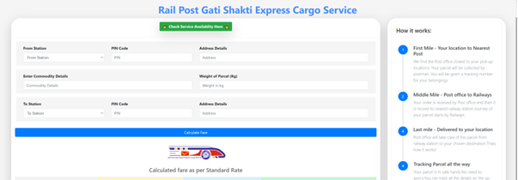

Front end was not connected to backend.at this stage. No admin panel.

**22 Dec 2022**

First 2 Set of APIs received from PMS Cris team

SMS API & Station Distance API. Both API implemented in PHP at server.

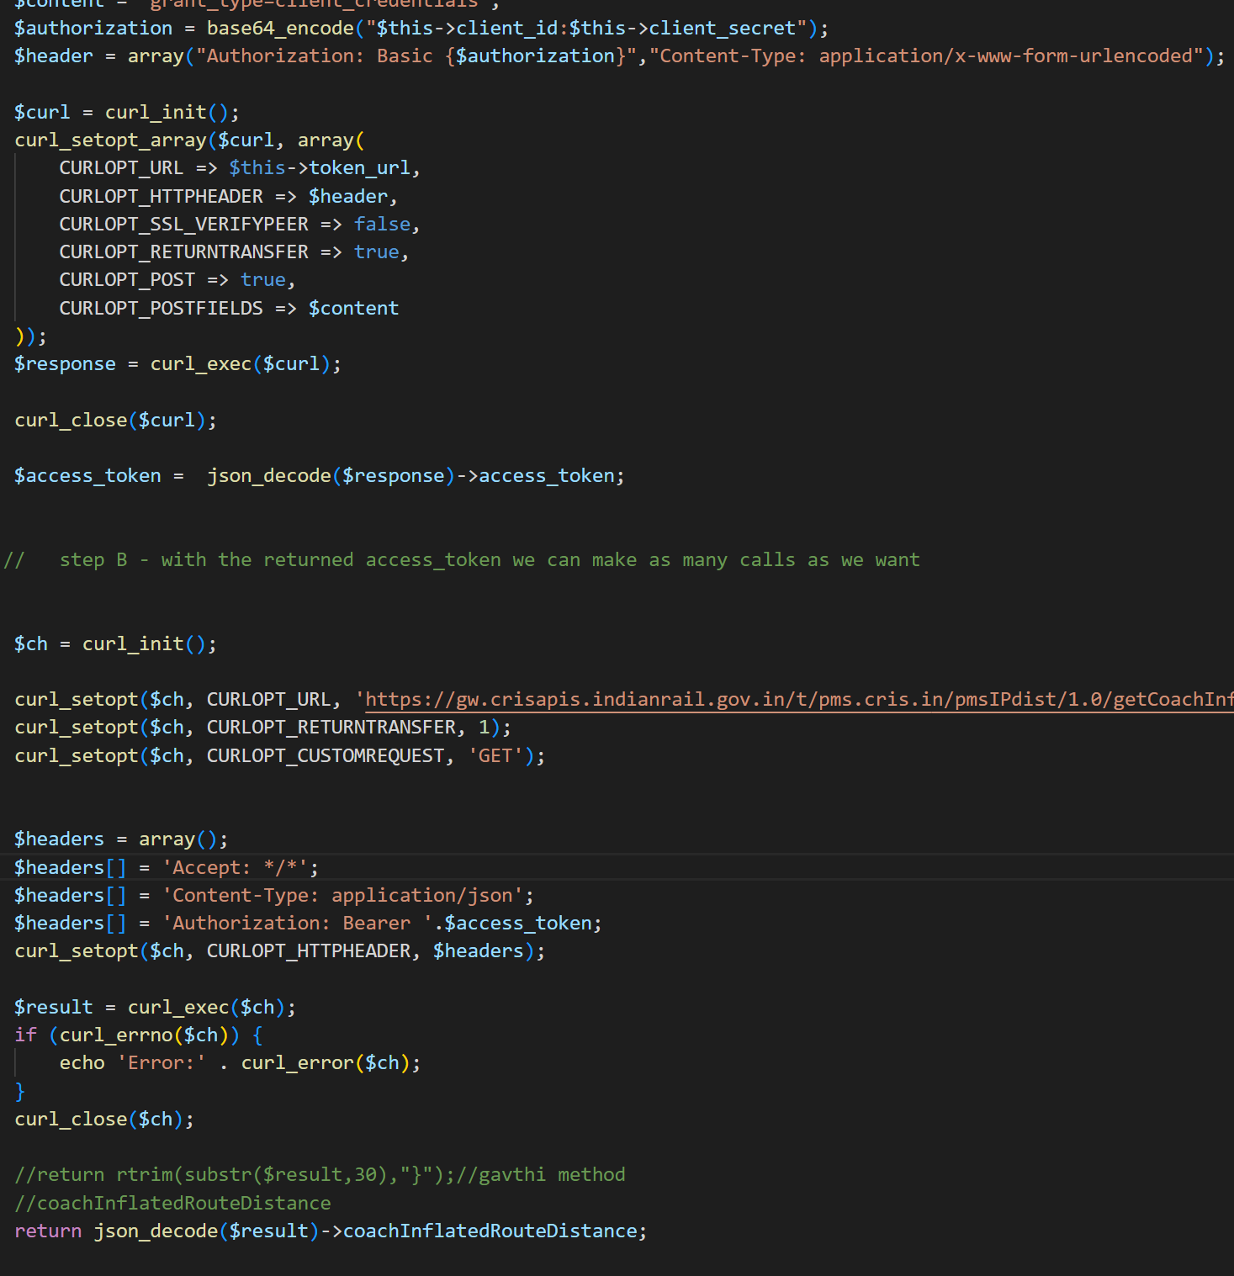

**23 Dec 2022**

Both APIs were integrated in JPP App using cURL logic and were able send SMS successfully

Distance API worked correctly in app and it was working perfectly for any 2 station distance.

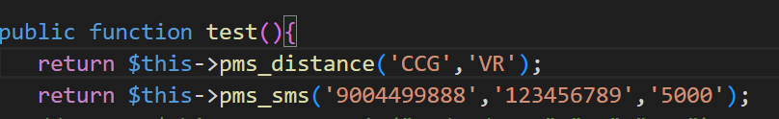

**26 Dec 2022**

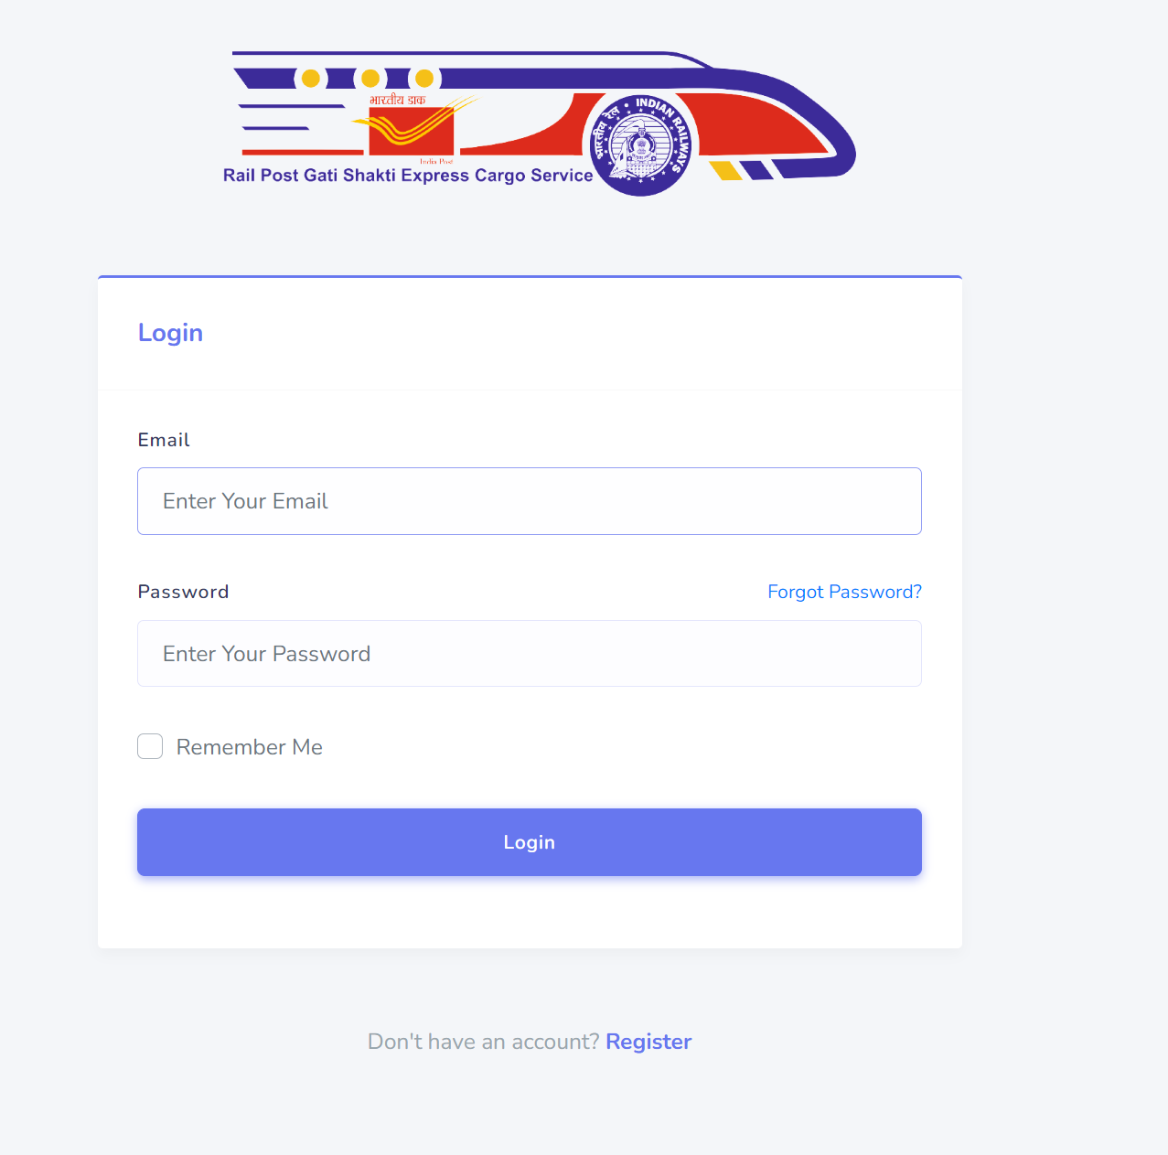

Worked on the logic of Login page and user registration page. Login controller was made with email as username. Home Design redirected after login.

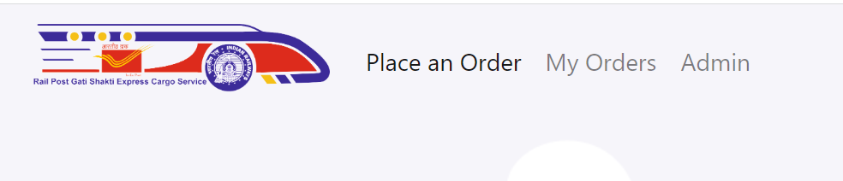

Worked on Navbar and to have all menus on transparent layout.

**27 Dec 2022**

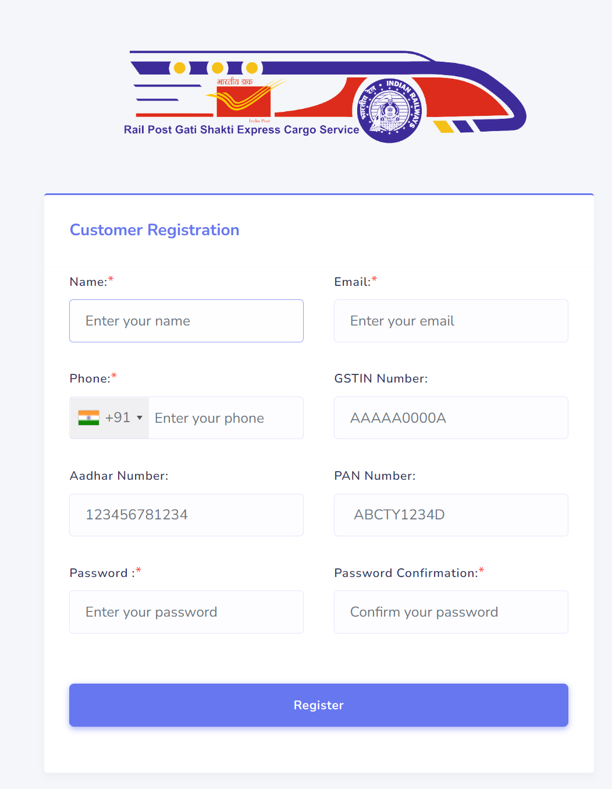

Registration page was developed and deployed with User model creation and linking it to Orders Table where user id will be foreign key to User Table.

**28 Dec 2023**

Navbar implemented for Amin Panel. Work started for admin panel

Both Post office and Railway Super admin side nav designed and linked.

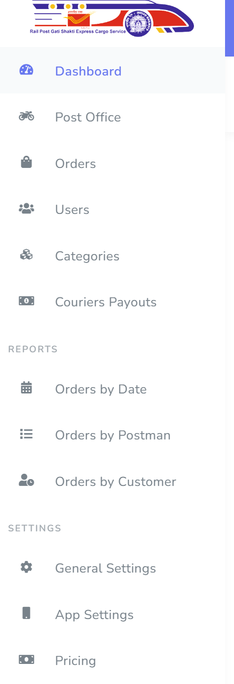

**29 Dec 2023**

Dashboard Page with flowcharts were implemented. All states were captured by admin.

Admin given absolute power for changing the state at anytime.

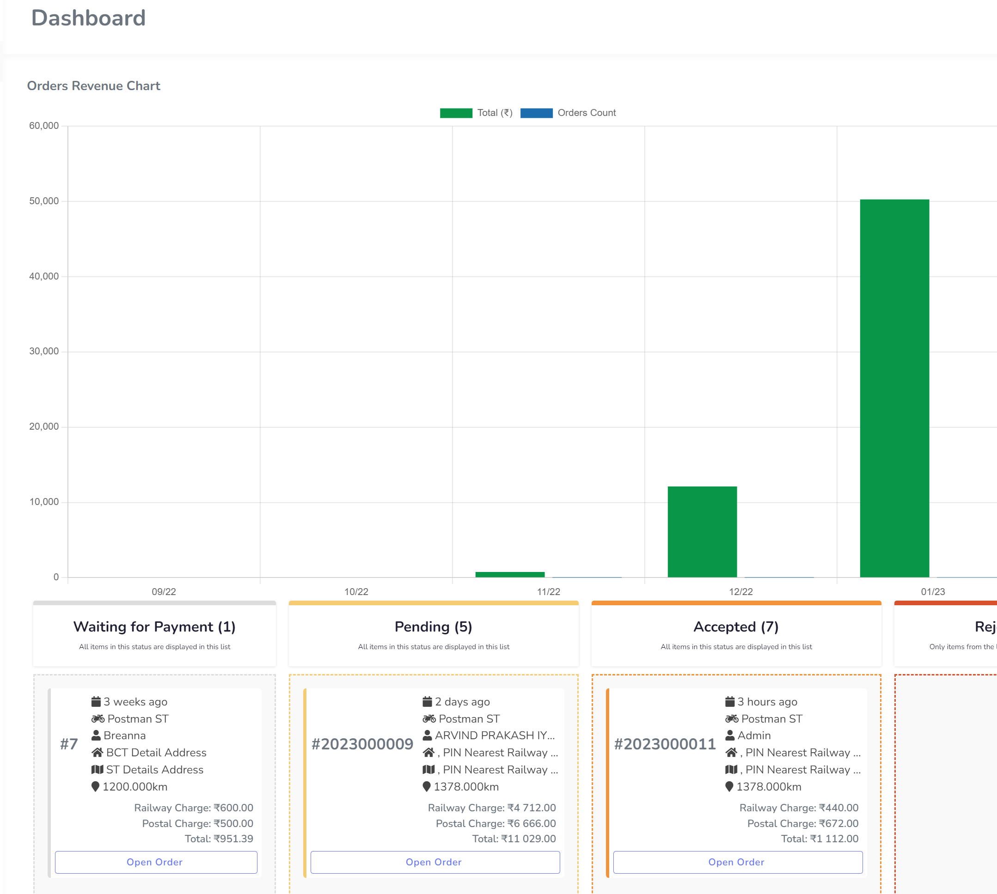

**30 Dec 2023**

Worked on Freight calculation on local database given by Nilesh sir.Ratetable and mastertable were provided by Nilesh sir.

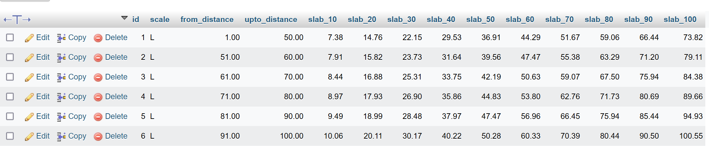

**2 Jan – 13 Jan**

Detail Dashboard activities were implemented on following topics in stipulated period of time. Can be seen after login with admin credentials.

* Post Office
* Orders
* Users
* Categories
* Couriers Payouts
* REPORTS
* Orders by Date
* Orders by Postman
* Orders by Customer
* SETTINGS
* General Settings
* App Settings
* Pricing
* Payments API
* Notifications
* Roles
* Permissions
* Currency
* Offline Payment Methods
* Legal
* Orders
* Export Print Reset Reload

**16th Jan 2023**

Confirm Order page was finally completed and its final page to give confirmation to post and user

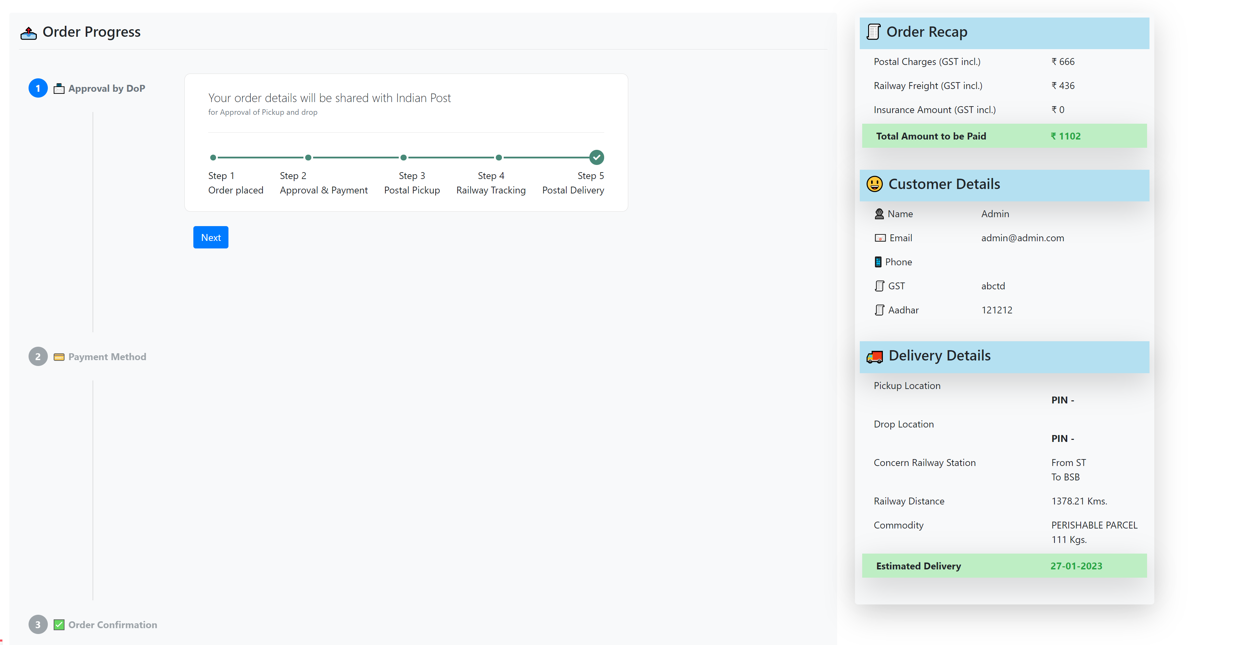

**17th Jan 2023**

One page design was made in the front page.

Freight calculations were fetched from Local server at this stage.

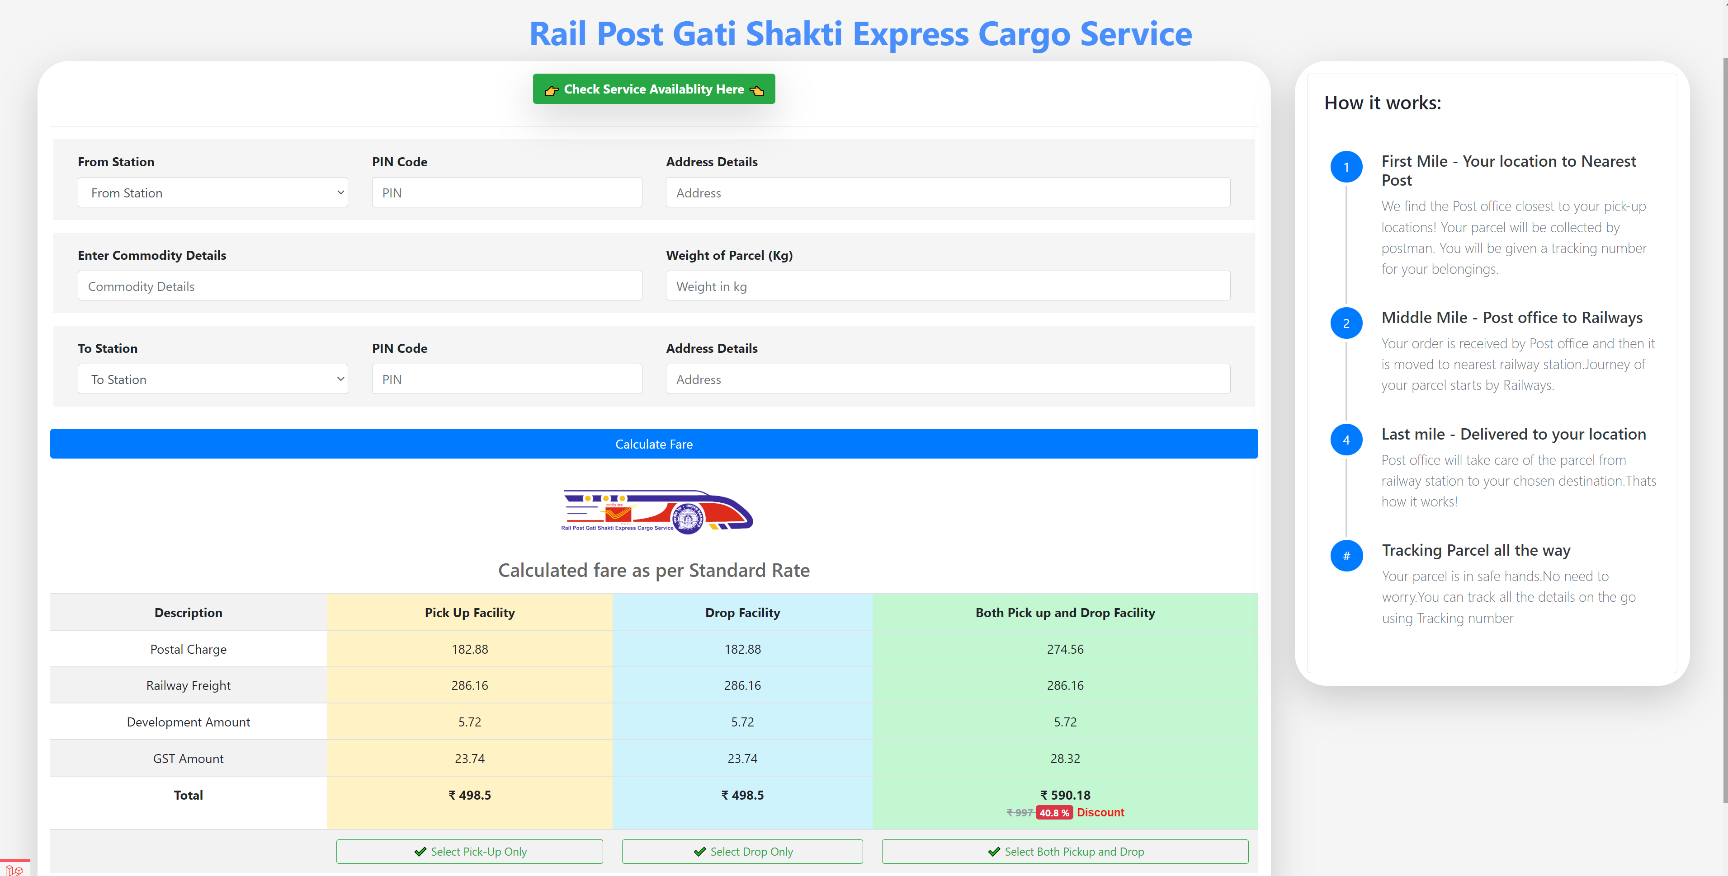

**18th Jan 2023**

* But ED/SPI sir told the design to change layout so need to change the design accordingly also api came for OD pair.

**19th Jan 2023 :**

Design Changed as per instruction of ED/SPI sir and new design as follows

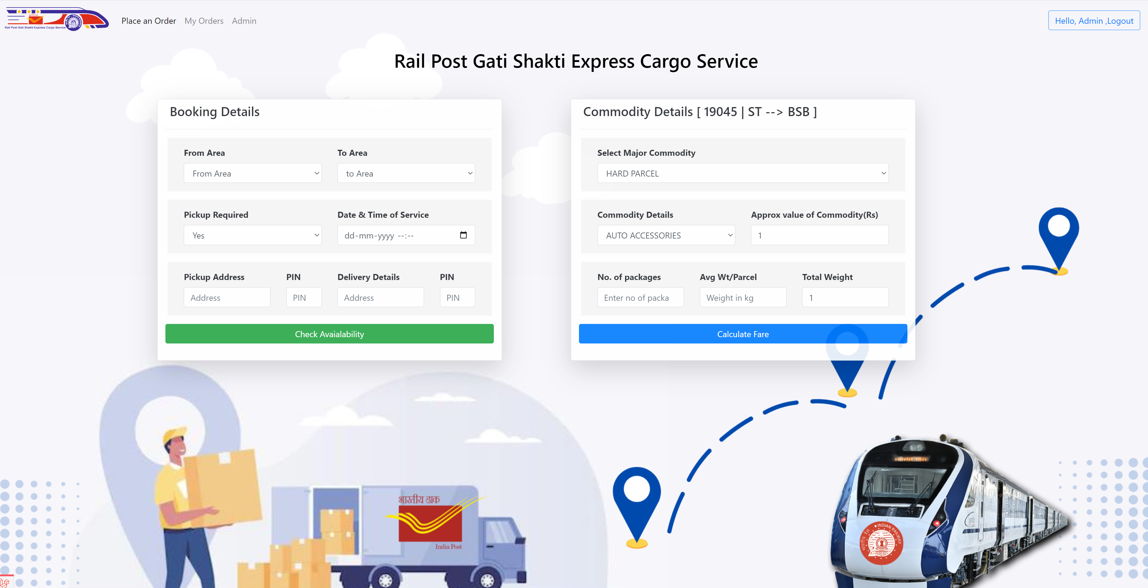

**20th Jan 2023** – Worked on JPP OD List API given by CRIS and implemented It on server. Integration due.

**21st JAN 2023 :**

JPP OD Pair API changed and new API implemented with Station between stations.

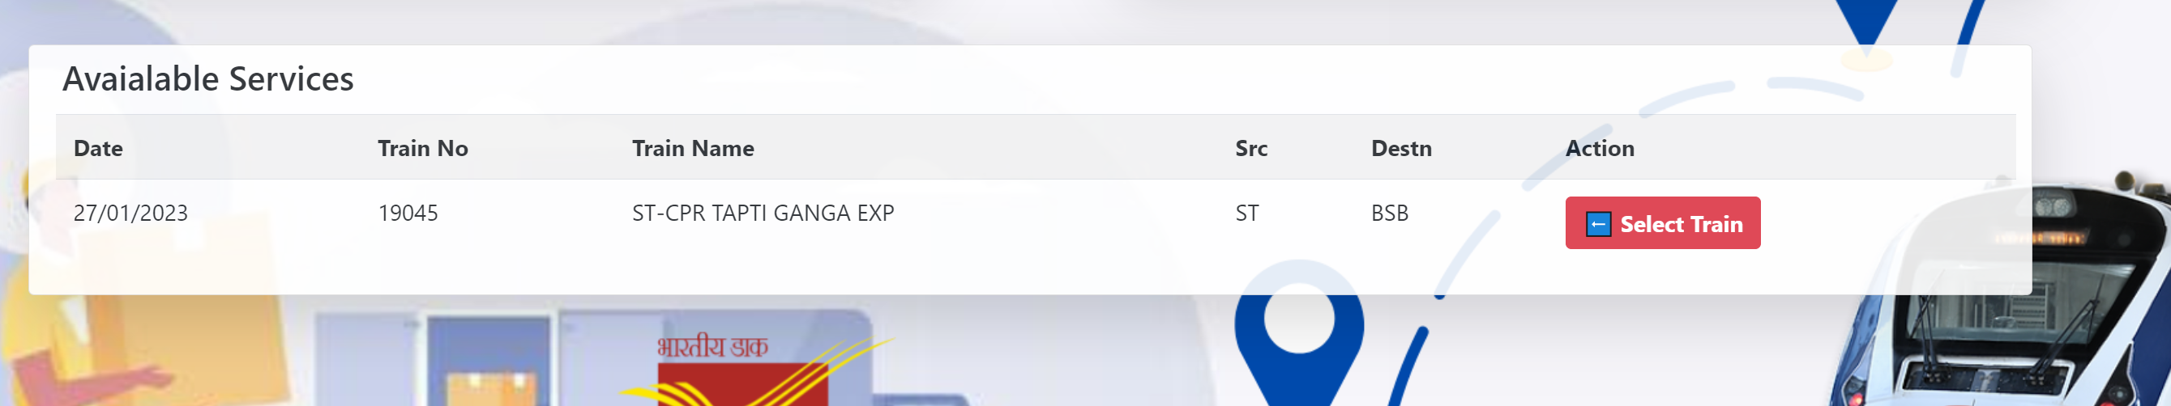

**22nd JAN 2023 :**

SBI Payment Gateway was explained by CRIS and tried to implement version of it.

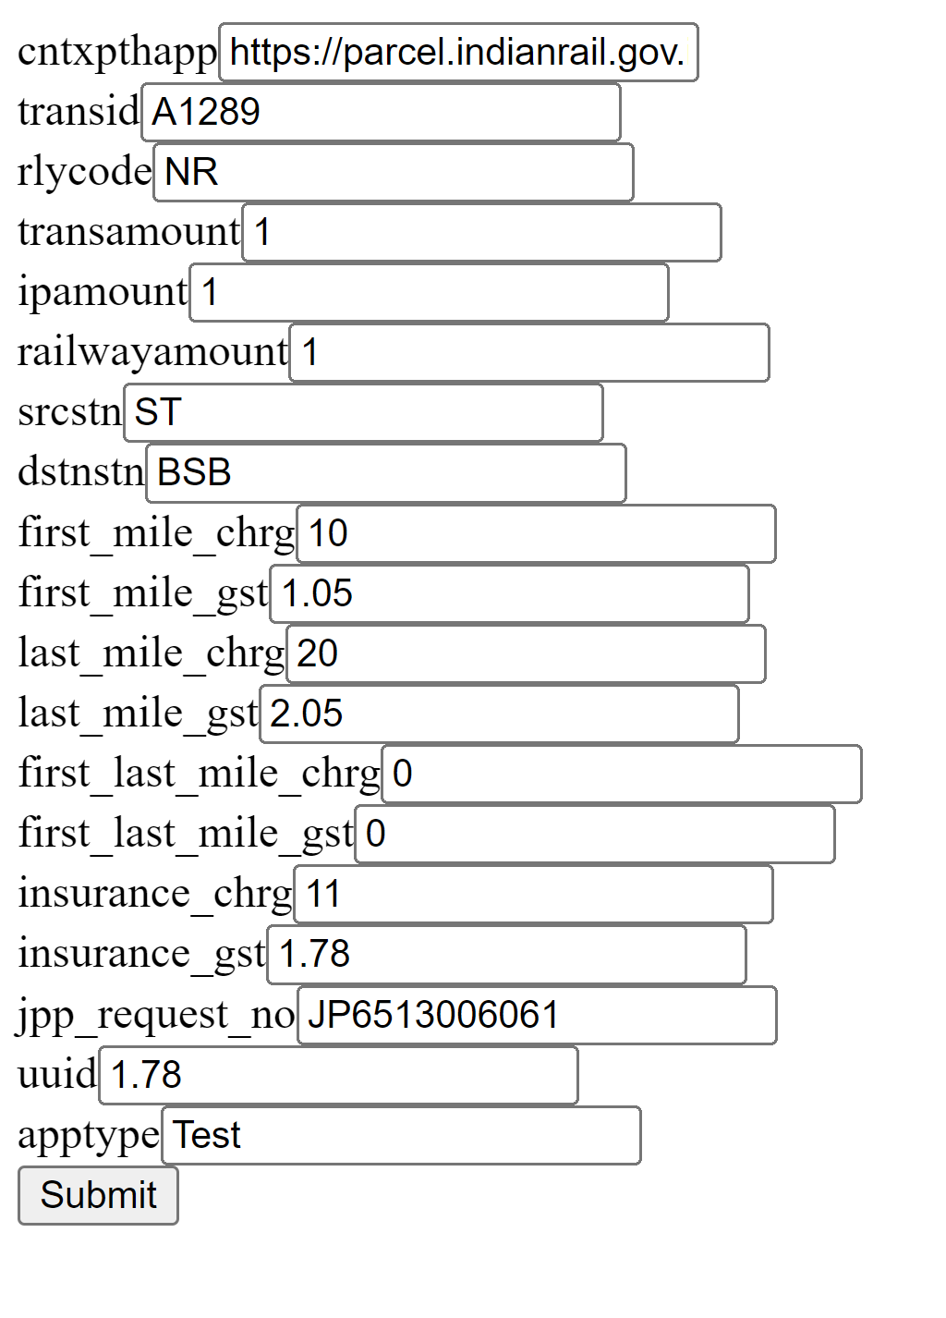

**23rd JAN 2023 :**

Worked on JPP Freight calculation API version 1 where basic freight rates were displayed.

Freight rates coming from PMS server at this point.

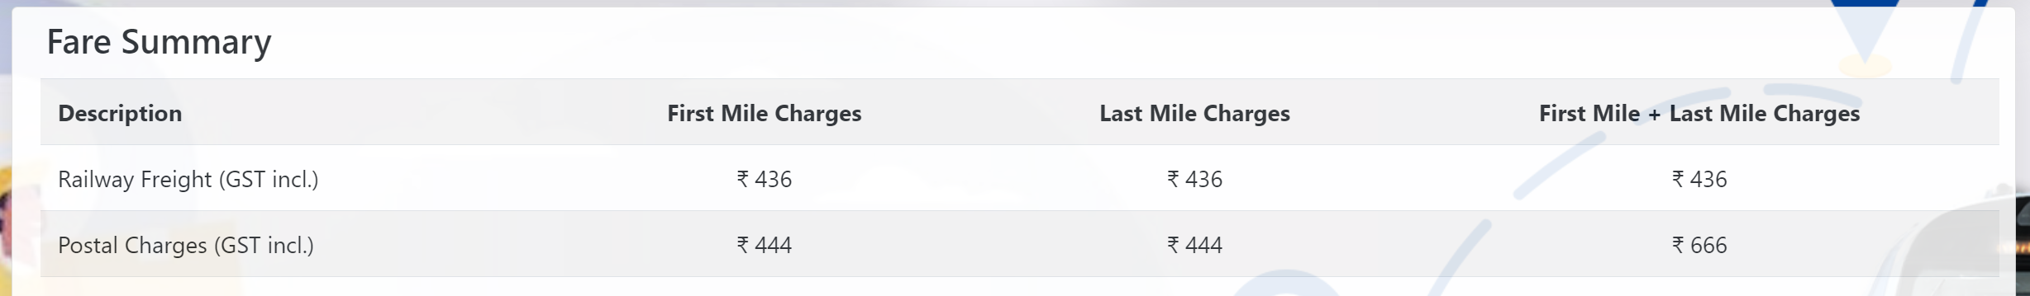

SBI Redirection worked for the first time but no response from SBI as server down

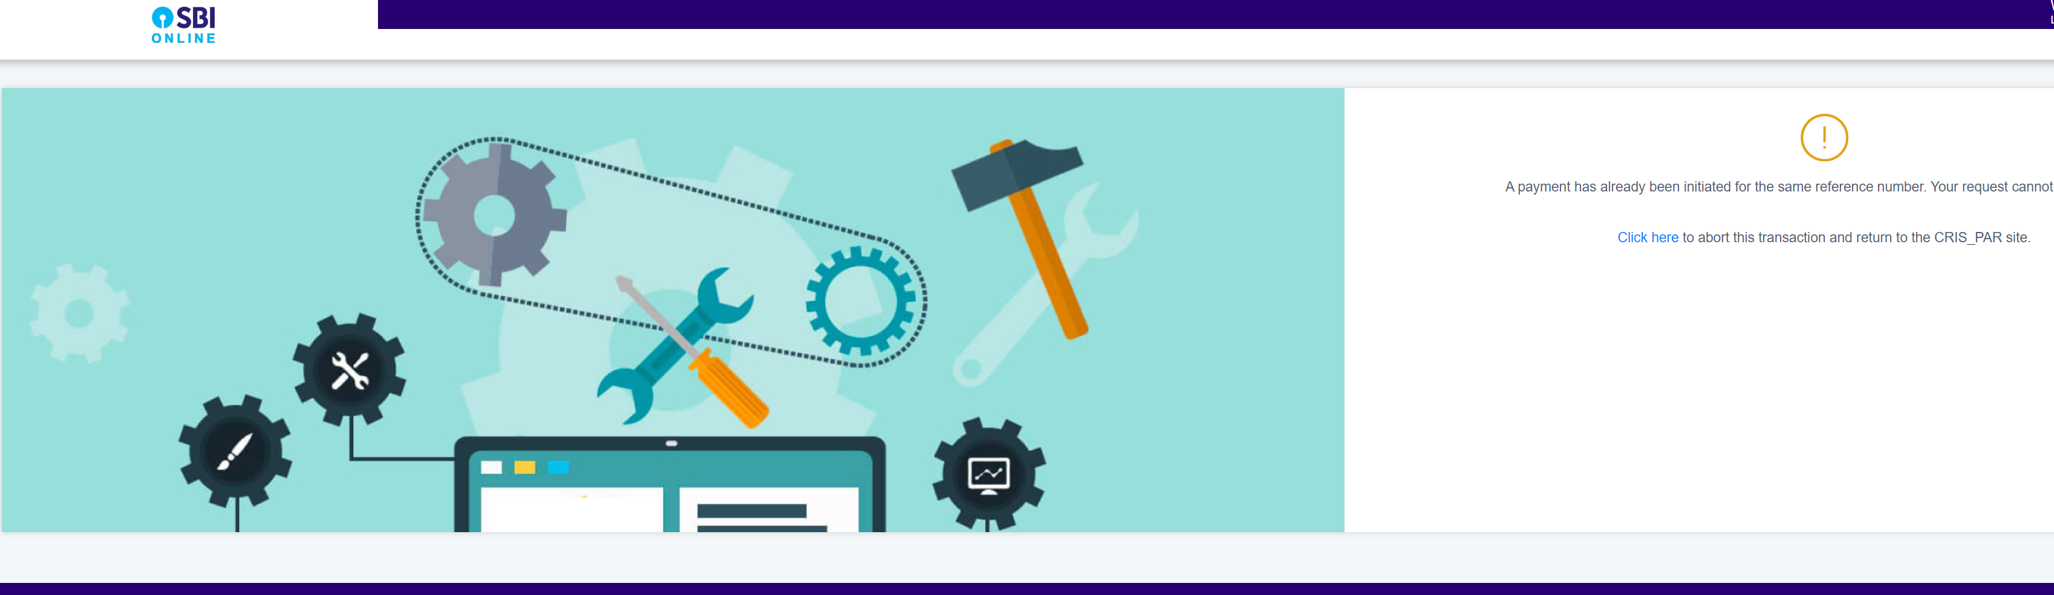

**24th JAN 2023:**

Version 2 of JPP Freight calculation was given in the evening at 6. Again made changes to SrcZONE and DestZone were include in distance API

My order was implemented properly with more clarity.

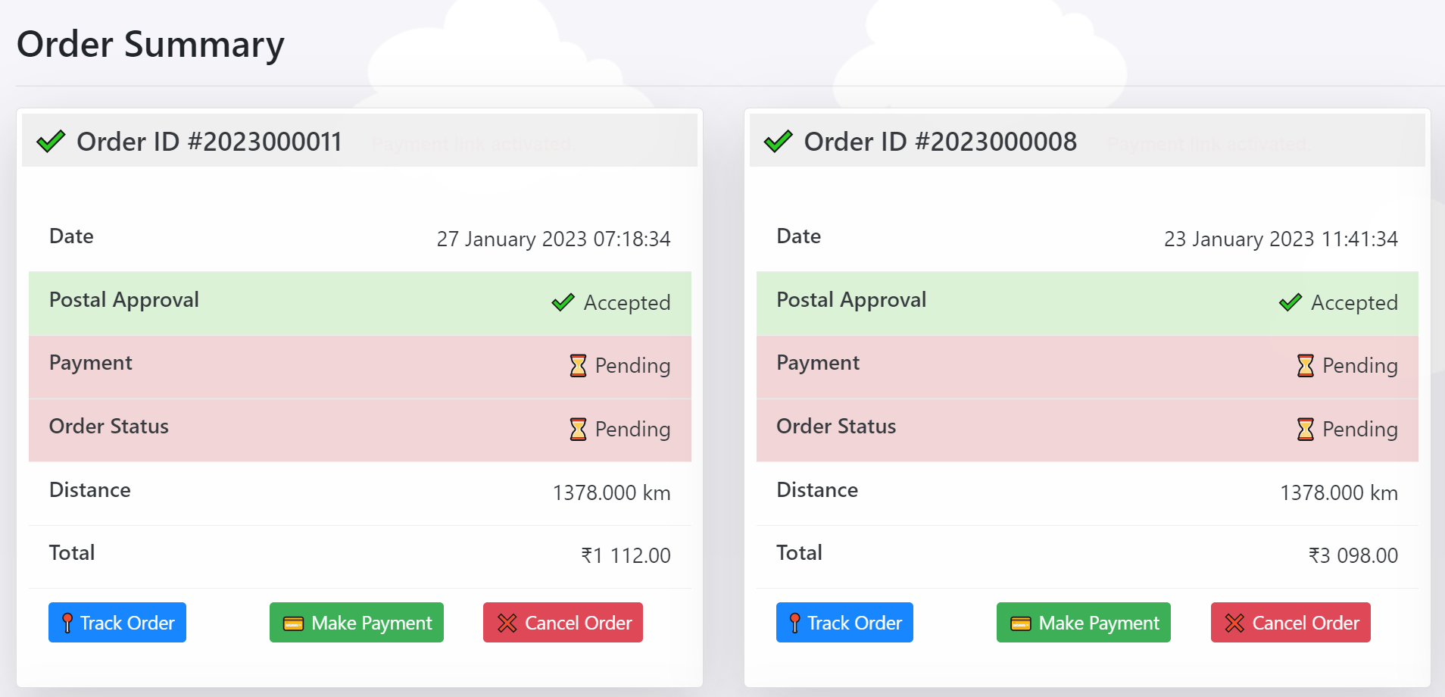

**25th JAN 2023:**

Version 3 of JPP Freight calculation was given on 25th JAN at around 9.44 pm. Again I have to make changes to front end desing and backed design as insurance component was calculated in the new version along with separate gst rates and username password filed.

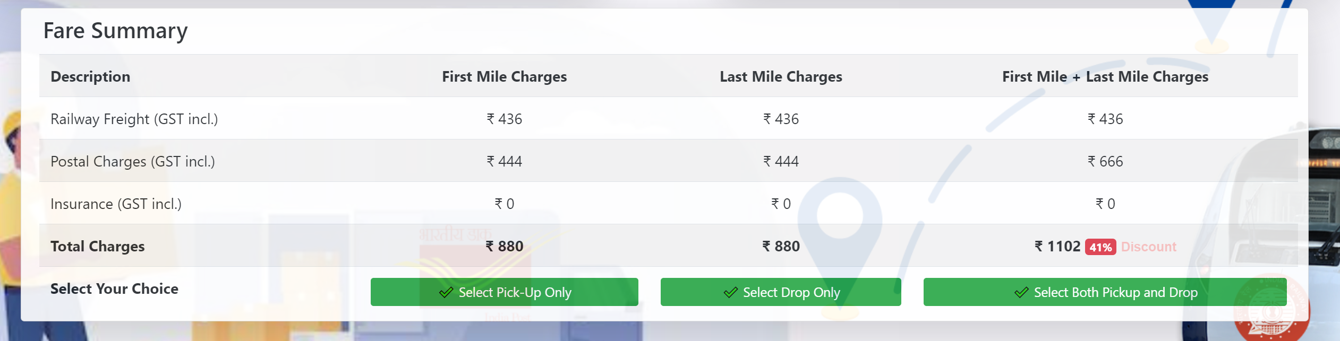

**27th JAN 2023:**

Implemented changes given by CRIS team. Added username and consignor email address in API.

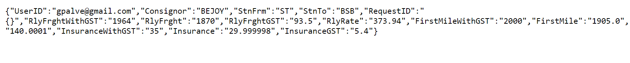

As per instruction of ED/SPI sir , tried availability of Train for next 10 days. But problem was API need to call 10 times to get data so need to have signle API which will tell availability for next 10 Days.

**Remarks: Very frequent changes by Team CRIS in API. Need to change entire logic time and again.**

**Need to finalize API structure so API can be implemented in project.**